Project Design Phase-II
Data Flow Diagram & User Stories

Date | 17 June 2026
Team ID | N/A
Project Name | AeroTrade (Student: Arcot Yashashivini)
Maximum Marks | 4 Marks

Data Flow Diagrams:
A Data Flow Diagram (DFD) is a traditional visual representation of the information flows within a system. A neat and clear DFD can depict the right amount of the system requirement graphically. It shows how data enters and leaves the system, what changes the information, and where data is stored.
Example: DFD Level 0 (Industry Standard)
Example: (Simplified)
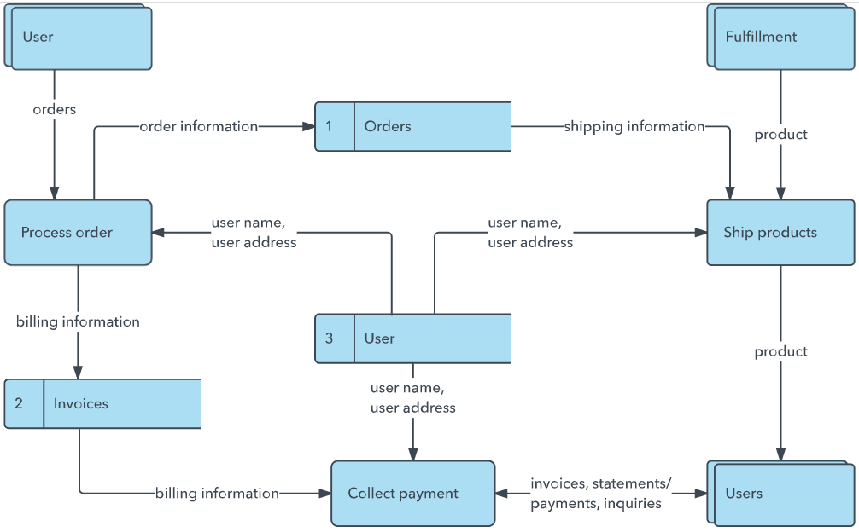


User Stories
Use the below template to list all the user stories for the product.
User Type | Functional Requirement (Epic) | User Story Number | User Story / Task | Acceptance criteria | Priority | Release
Customer (Web user) | Registration | USN-1 | As a user, I can register for the application by entering my email, password, and confirming my password. | I can access my account / dashboard | High | Sprint-1
Customer (Web user) | Registration | USN-2 | As a user, I will receive confirmation email once I have registered for the application | I can receive confirmation email & click confirm | High | Sprint-1
Customer (Web user) | Login | USN-5 | As a user, I can log into the application by entering email & password | I can access my account / dashboard | High | Sprint-1
Customer (Web user) | Dashboard | USN-6 | As a trader, I can view real-time price fluctuations and search stocks. | List of stocks loaded; search filters assets. | High | Sprint-1
Customer (Web user) | Dashboard | USN-7 | As a trader, I can view 24h historical charts for stocks. | Sparkline canvas graph draws stock trend lines. | Medium | Sprint-2
Customer (Web user) | Trading | USN-8 | As a trader, I can BUY and SELL stock shares in the portfolio. | Cash balances verified, holdings computed. | High | Sprint-2
Administrator | Admin CRUD | USN-9 | As an admin, I can add, edit, or delete stocks from the portal. | Data updates persist in MongoDB immediately. | Medium | Sprint-3
Administrator | Admin Logs | USN-10 | As an admin, I can view all user transactions globally. | Scrolling log shows email, type, stock, quantity. | Medium | Sprint-3
Customer (Web user) | News Ticker | USN-11 | As a user, I can view scrolling feeds from Google News RSS. | Running banner text, popup news details. | Low | Sprint-4
Customer (Web user) | SVG Chart | USN-12 | As a user, I can see my sector asset allocations in an SVG chart. | Sector pie/donut divisions render dynamically. | Low | Sprint-4

